**https://courses.lumenlearning.com/cuny-hunter-collegealgebra/chapter/applications-of-quadratic-functions/**

**Objects in free fall**

A very common and easy-to-understand application is the height of a ball thrown at the ground off a building. Because gravity will make the ball speed up as it falls, a quadratic equation can be used to estimate its height any time before it hits the ground. *Note: The equation isn’t completely accurate, because friction from the air will slow the ball down a little. For our purposes, this is close enough.*

### Example

A ball is thrown off a building from 200 feet above the ground. Its starting velocity (also called *initial velocity*) is −10

feet per second. (The negative value means it’s heading toward the ground.)

The equation h=−16t2−10t+200

 can be used to model the height of the ball after t

seconds. About how long does it take for the ball to hit the ground?

Show Solution

When the ball hits the ground, the height is 0. Substitute 0 for h

.

h=−16t2−10t+2000=−16t2−10t+200−16t2−10t+200=0

This equation is difficult to solve by factoring or by completing the square, so solve it by applying the Quadratic Formula, x=−b±√b2−4ac2a

. In this case, the variable is t rather than x. a=−16,b=−10, and c=200

.

t=−(−10)±√(−10)2−4(−16)(200)2(−16)

Simplify. Be very careful with the signs.

t=10±√100+12800−32=10±√12900−32

Use a calculator to find both roots.

t

is approximately −3.86 or 3.24

.

Consider the roots logically. One solution, −3.86

, cannot be the time because it is a negative number. The other solution, 3.24

seconds, must be when the ball hits the ground.

#### Answer

The ball hits the ground approximately 3.24

seconds after being thrown.

**Example: Applying the Vertex and [latex]*x[/latex]*-Intercepts of a Parabola**

A ball is thrown upward from the top of a 40 foot high building at a speed of 80 feet per second. The ball’s height above ground can be modeled by the equation H(t)=−16t2+80t+40

.

a. When does the ball reach the maximum height?

b. What is the maximum height of the ball?

c. When does the ball hit the ground?

Solution

a. The ball reaches the maximum height at the vertex of the parabola.

h=−802(−16) =8032 =52 =2.5

The ball reaches a maximum height after 2.5 seconds.

b. To find the maximum height, find the *y*coordinate of the vertex of the parabola.

k=H(−b2a) =H(2.5) =−16(2.5)2+80(2.5)+40 =140

The ball reaches a maximum height of 140 feet.

c. To find when the ball hits the ground, we need to determine when the height is zero, H(t)=0

.

We use the quadratic formula.

t=−80±√802−4(−16)(40)2(−16) =−80±√8960−32

Because the square root does not simplify nicely, we can use a calculator to approximate the values of the solutions.

t=−80−√8960−32≈5.458ort=−80+√8960−32≈−0.458

The second answer is outside the reasonable domain of our model, so we conclude the ball will hit the ground after about 5.458 seconds.

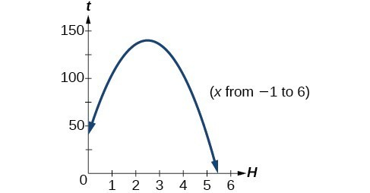

**EXAMPLE**

A rock is thrown upward from the top of a 112-foot high cliff overlooking the ocean at a speed of 96 feet per second. The rock’s height above ocean can be modeled by the equation H(t)=−16t2+96t+112

.

a. When does the rock reach the maximum height?

b. What is the maximum height of the rock?

c. When does the rock hit the ocean?

Solution

a. 3 seconds

b. 256 feet

c. 7 seconds

### Applications of quadratic functions: determining the width of a border

The area problem below does not look like it includes a Quadratic Formula of any type, and the problem seems to be something you have solved many times before by simply multiplying. But in order to solve it, you will need to use a quadratic equation.

### Example

Bob made a quilt that is 4 ft ×

5 ft. He has 10 sq. ft. of fabric he can use to add a border around the quilt. How wide should he make the border to use all the fabric? (The border must be the same width on all four sides.)

Show Solution

Sketch the problem. Since you don’t know the width of the border, you will let the variable x

 represent the width.

In the diagram, the original quilt is indicated by the red rectangle. The border is the area between the red and blue lines.

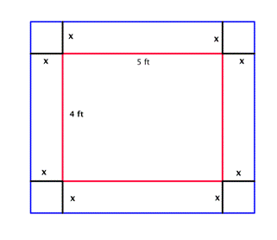

Since each side of the original 4 by 5 quilt has the border of width *x* added, the length of the quilt with the border will be 5+2x

, and the width will be 4+2x

.

(Both dimensions are written in terms of the same variable, and you will multiply them to get an area! This is where you might start to think that a quadratic equation might be used to solve this problem.)

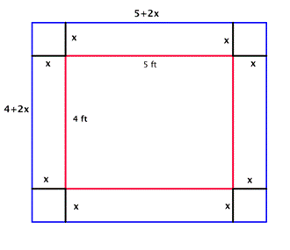

You are only interested in the area of the border strips. Write an expression for the area of the border.

Area of border = Area of the blue rectangle minus the area of the red rectangle

Area of border=(4+2x)(5+2x)–(4)(5)

There are 10 sq ft of fabric for the border, so set the area of border to be 10.

10=(4+2x)(5+2x)–20

Multiply (4+2x)(5+2x)

.

10=20+8x+10x+4x2–20

Simplify.

10=18x+4x2

Subtract 10 from both sides so that you have a quadratic equation in standard form and can apply the Quadratic Formula to find the roots of the equation.

0=18x+4x2−10or4x2−102(2x2+9x−5)=0

Factor out the greatest common factor, 2, so that you can work with the simpler equivalent equation, 2x2+9x–5=0

.

2(2x2+9x−5)=02(2x2+9x−5)2=022x2+9x−5=0

Use the Quadratic Formula. In this case, a=2,b=9

, and c=−5

.

x=−b±√b2−4ac2ax=−9±√92−4(2)(−5)2(2)

Simplify.

x=−9±√1214=−9±114

Find the solutions, making sure that the ±

is evaluated for both values.

x=−9+114=24=12=0.5orx=−9−114=−204=−5

Ignore the solution x=−5

, since the width could not be negative.

#### Answer

The width of the border should be 0.5 ft.

### Finding the maximum and minimum values of a quadratic function

There are many real-world scenarios that involve finding the maximum or minimum value of a quadratic function, such as applications involving area and revenue.

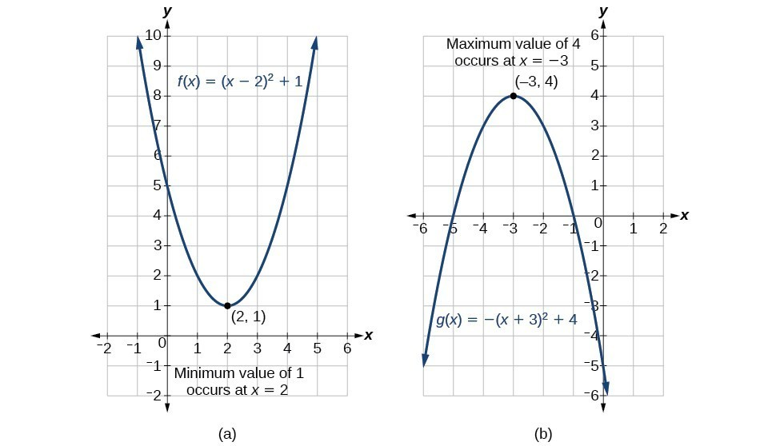[https://s3-us-west-2.amazonaws.com/courses-images/wp-content/uploads/sites/2862/2017/12/26165501/calculator.png](https://s3-us-west-2.amazonaws.com/oerfiles/College+Algebra/calculator.html)

### ExAMPLE

Find two numbers x

and y

whose difference is 100 and whose product is a minimum.

Show Answer

### Example: Finding the Maximum Value of a Quadratic Function

A backyard farmer wants to enclose a rectangular space for a new garden within her fenced backyard. She has purchased 80 feet of wire fencing to enclose three sides, and she will use a section of the backyard fence as the fourth side.

1. Find a formula for the area enclosed by the fence if the sides of fencing perpendicular to the existing fence have length L
2. .
3. What dimensions should she make her garden to maximize the enclosed area?

Solution

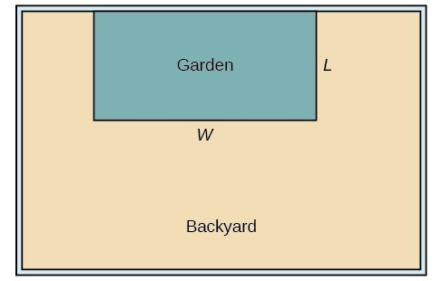

Let’s use a diagram such as the one above to record the given information. It is also helpful to introduce a temporary variable, W, to represent the width of the garden and the length of the fence section parallel to the backyard fence.

1)  We know we have only 80 feet of fence available, and L+W+L=80

, or more simply, 2L+W=80. This allows us to represent the width, W, in terms of L

.

W=80−2L

Now we are ready to write an equation for the area the fence encloses. We know the area of a rectangle is length multiplied by width, so

 A=LW=L(80−2L)A(L)=80L−2L2

This formula represents the area of the fence in terms of the variable length L

. The function, written in general form, is

A(L)=−2L2+80L

.

2) The quadratic has a negative leading coefficient, so the graph will open downward, and the vertex will be the maximum value for the area. In finding the vertex, we must be careful because the equation is not written in standard polynomial form with decreasing powers. This is why we rewrote the function in general form above. Since a

 is the coefficient of the squared term, a=−2,b=80, and c=0

.

To find the vertex:

h=−802(−2)k=A(20) =20and =80(20)−2(20)2 =800

The maximum value of the function is an area of 800 square feet, which occurs when L=20

feet. When the shorter sides are 20 feet, there is 40 feet of fencing left for the longer side. To maximize the area, she should enclose the garden so the two shorter sides have length 20 feet and the longer side parallel to the existing fence has length 40 feet.

#### Analysis of the Solution

This problem also could be solved by graphing the quadratic function. We can see where the maximum area occurs on a graph of the quadratic function below.

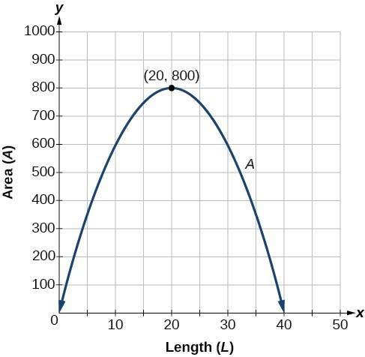

### How To: Given an application involving revenue, use a quadratic equation to find the maximum.

1. Write a quadratic equation for revenue.
2. Find the vertex of the quadratic equation.
3. Determine the y
4. -value of the vertex.

### Example: Finding Maximum Revenue

The unit price of an item affects its supply and demand. That is, if the unit price goes up, the demand for the item will usually decrease. For example, a local newspaper currently has 84,000 subscribers at a quarterly charge of $30. Market research has suggested that if the owners raise the price to $32, they would lose 5,000 subscribers. Assuming that subscriptions are linearly related to the price, what price should the newspaper charge for a quarterly subscription to maximize their revenue?

Solution

Revenue is the amount of money a company brings in. In this case, the revenue can be found by multiplying the price per subscription times the number of subscribers, or quantity. We can introduce variables, p

 for price per subscription and Q for quantity, giving us the equation Revenue=pQ

.

Because the number of subscribers changes with the price, we need to find a relationship between the variables. We know that currently p=30

and Q=84,000. We also know that if the price rises to $32, the newspaper would lose 5,000 subscribers, giving a second pair of values, p=32 and Q=79,000

. From this we can find a linear equation relating the two quantities. The slope will be

m=79,000−84,00032−30 =−5,0002 =−2,500

This tells us the paper will lose 2,500 subscribers for each dollar they raise the price. We can then solve for the y-intercept.

 Q=−2500p+bSubstitute in the point Q=84,000 and p=3084,000=−2500(30)+bSolve for b b=159,000

This gives us the linear equation Q=−2,500p+159,000

relating cost and subscribers. We now return to our revenue equation.

Revenue=pQRevenue=p(−2,500p+159,000)Revenue=−2,500p2+159,000p

We now have a quadratic function for revenue as a function of the subscription charge. To find the price that will maximize revenue for the newspaper, we can find the vertex.

h=−159,0002(−2,500) =31.8

The model tells us that the maximum revenue will occur if the newspaper charges $31.80 for a subscription. To find what the maximum revenue is, we evaluate the revenue function.

maximum revenue=−2,500(31.8)2+159,000(31.8) =2,528,100

#### Analysis of the Solution

This could also be solved by graphing the quadratic. We can see the maximum revenue on a graph of the quadratic function.

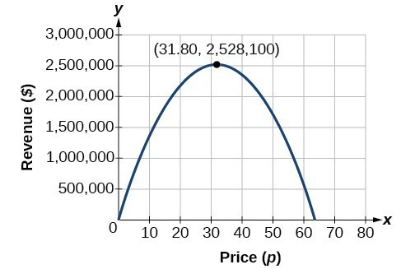

### Try It

A coordinate grid has been superimposed over the quadratic path of a basketball in the picture below. Find an equation for the path of the ball. Does the shooter make the basket?

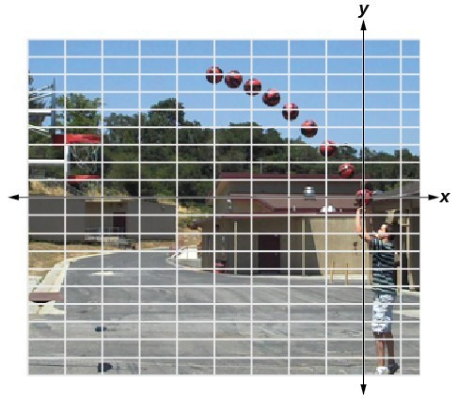

(credit: modification of work by Dan Meyer)

Solution

The path passes through the origin and has vertex at (−4, 7)

, so (h)x=−716(x+4)2+7. To make the shot, h(−7.5) would need to be about 4 but h(−7.5)≈1.64; he doesn’t make it.